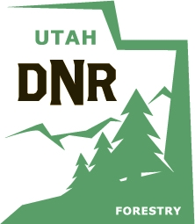
For Office Use Only

Region
School ID
Disqualified

Poster Entry Form
2020
Utah Arbor Day Poster Contest
(one per poster)

Student Information
Student's Name
Grade
Teacher's Name
Parent/Guardian
Student’s Home Phone No.*

School Information

School
School District
Mailing Address
City, St, Zip
School Telephone No.
Arbor Day Coordinator Name
Arbor Day Coordinator Email

Tape Entry Form to the Back of Each Poster

Poster Entry Deadline: March 10, 2020

Please photocopy this Poster Entry Form. A Poster Entry Form must be attached to each poster sent to the Arbor Day Committee. All Utah students in grades K-6 and special education are eligible to enter the Arbor Day Poster Contest. Please fill out this form so it is legible. The certificates are printed using this information and if the students name is not legible then some certificates are printed with incorrect student names. The forms on the website (arborday.utah.gov) can be filled out in MS Word or Adobe Reader and then printed.

Each School May Submit Only One Poster Per Grade K-6 and Special Education to the State Arbor Day Poster Contest (Maximum of 8).

*This information will only be used to contact poster contest winners.

