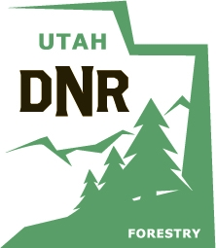
School Report Form
2020
Utah Arbor Day Poster Contest
(one per school)

School Name
School District
City
Total Number of posters in this packet (Maximum of 8)

School Winners

Grade | Student’s Name
Kindergarten
1st
2nd
3rd
4th
5th
6th
Special Ed

Only one poster per grade and special education may
be submitted to the Arbor Day Poster Contest! (Maximum of 8)

Please fill out this form so it is legible. The certificates are printed using this information and if the students name is not legible then some certificates are printed with incorrect student names. The forms on the website (arborday.utah.gov) can be filled out in MS Word or Adobe Reader and then printed.

Poster Entry Deadline: (must arrive by) March 10, 2020

Please mail this form along with the school's winning posters to:
Arbor Day Poster Contest
Division of Forestry, Fire and State Lands
1594 W North Temple, Suite 3520
SLC, UT 84116

